TRUCK GROUNDING SYSTEM
STATIC EARTH REEL MONITOR

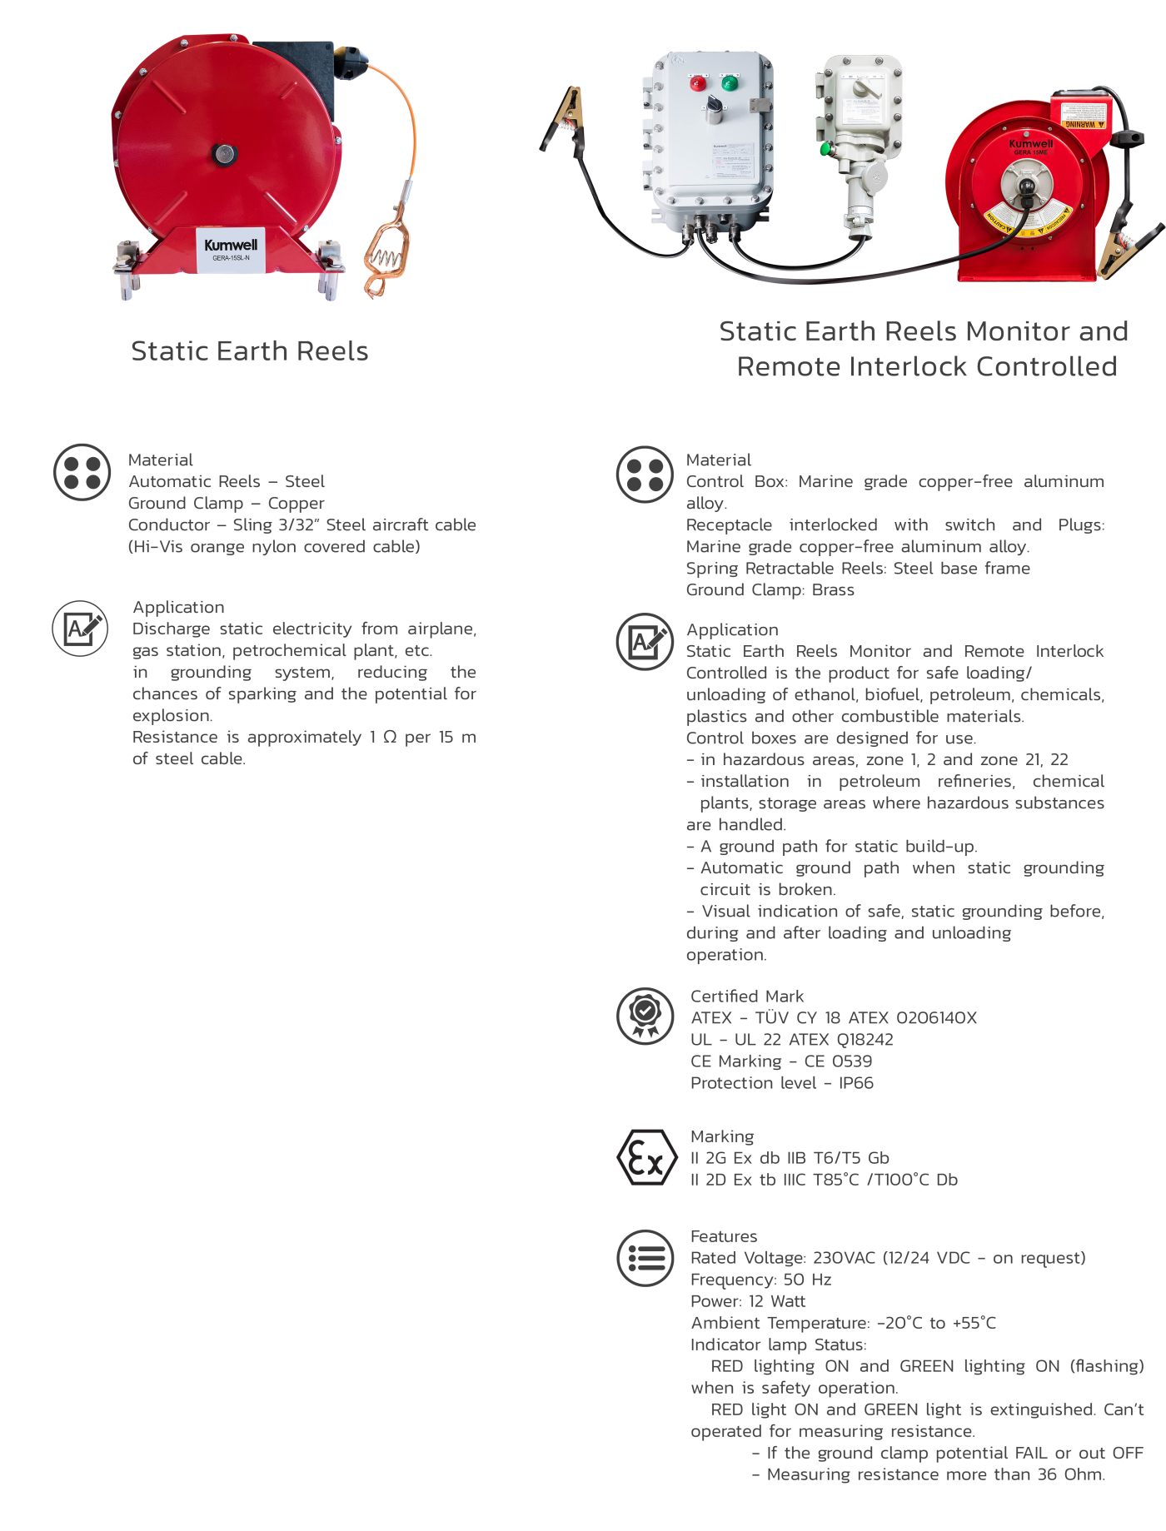

Kumwell GERA-15ME-AEX is an advanced static grounding system designed to protect personnel, equipment, and facilities during the transfer of flammable and combustible materials such as petroleum products, chemicals, solvents, ethanol, biofuels etc.. in hazardous areas.

GERA-15ME-AEX provides continuous verification of grounding connections during the loading and unloading of flammable and combustible materials. By monitoring the earth path between transport vehicles and ground, it prevents the build-up of hazardous static electricity and reduces the risk of fire or explosion.

GERA-15ME-AEX offers an efficient and cost-effective solution for truck, tanker, railcar, and container grounding applications. Its rugged design, simple installation, and low maintenance requirements help minimize operational downtime while enhancing safety compliance. By preventing unsafe loading conditions and reducing the likelihood of costly incidents, the system delivers long-term reliability and a lower total cost of ownership.

